
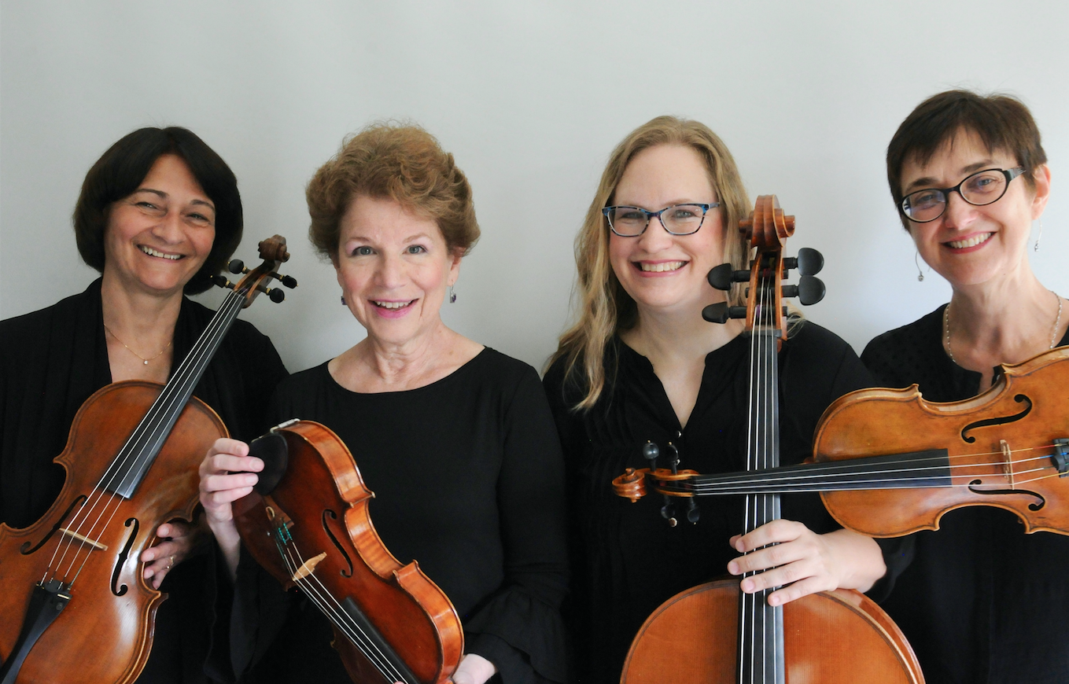
The Camerata String Quartet

Providing Elegant Music for Special Occasions

Leyla Sanyer and Maureen McCarty – violin, Liz Deger – viola, Amy Harr - cello

CONTRACT FOR PERFORMANCE

E

Please return this contract with your signature & deposit check
(or Venmo – Leyla Sanyer) as soon as possible to reserve your date.
A signed copy will be mailed to you after requests and fees have been confirmed.

The Camerata String Quartet agrees to provide musical services for the following event at the time and place indicated below.

Date of Contract: Date of Event: Time: Type of Event:

Place of Event: Starting time of music: Ending time:

Address: City/State: Zip:

Please note: Due to the fragility of the string instruments, the string quartet will not be able to perform outdoors in
inclement weather unless an acceptable shelter is provided. This includes heavy winds, hot sun, a light mist or even the threat of rain. There will be no additional charge for the use of our white canopy, but we must be allowed to use it if necessary. If weather prevents a performance, no refund will be given since the quartet’s time is invested in preparing for and travel.

Performance fees:

Wedding Ceremony: $675 (prelude, processional, special ceremony music, recessional and postlude).
Wedding Reception: Same location $350 per hour. New location: $400 first hour, $350 each additional hour.
Receptions, dinner parties and other special events: $650 for first hour, $400 each additional hour.
Travel fee: $100 per hour (if over 25 miles from downtown Madison). Canopy use for outdoors: Complementary
Special Requests: $40-$75 (music arranging, music outside of quartet repertoire, extra rehearsal time with soloists)
Event fee: Travel fee: Special request fee: TBD TOTAL FEE:

Deposit: $ to hold your date/time to be returned with this signed contract.
We request full payment two weeks prior to date of event: Balance of $ due on or before Saturday, (Month, day, year)
Checks should be made payable to Leyla Sanyer and sent to the address below or use VENMO (Leyla Sanyer).
For CSQ use only
Payment Received:

Date:
Amount:
Check #
Signature

Date:
Amount:
Check #
Signature

Employer of Camerata String Quartet: Camerata String Quartet Manager:

Name Leyla Sanyer

Street Address 102 Holiday Court

City, State, Zip Verona, WI 53593

Phone 608-516-1339
cameratastringquartet@gmail.com
Email
www.cameratastrings.com

___________________________________ _________________________________________
Signature of Employer Date Signature for the Camerata Quartet Date

A signed copy of this contract will be sent to you after requests and fees have been finalized.
Please tell us how you found Camerata String Quartet?_____________________________ and
Please plan to include “The Camerata String Quartet” in your printed wedding program.

